 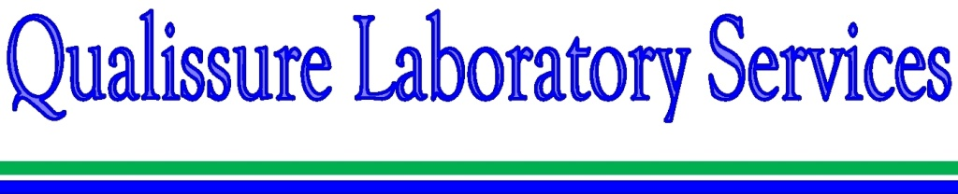

***HOME SERVICES CERTIFICATES BLOGS ABOUT US CONTACT CAREER***

~~NETWORK~~ GALLERY 1.PHOTO, 2. VIDEO

**SERVICES** Qualissure Laboratory Services (QLS) , is a professional services company providing Environment monitoring, Food testing , Environmental Consultancy , Technical Training and Consultancy for Laboratory Set-up . QLS is engaged in various R&D activities in the field of Environment & Food Testing .

QLS was built on the strong commitment of quality and integrity in their services.

**~~LABORATORIES~~**

**ACCREDITATION**

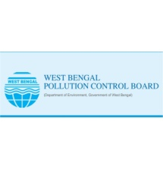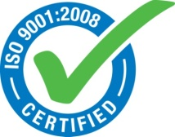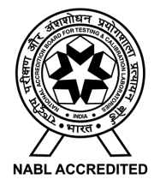



WHAT’S NEW

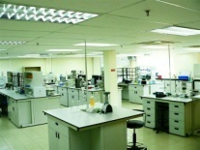 **Laboratory Setup**

Setting up a new laboratory involves critical decisions at every step of the project – from determining the space, need analysis, equipment selection to validation and training.

